Configure Layer 3 Switching and Inter-VLAN Routing Addressing Table

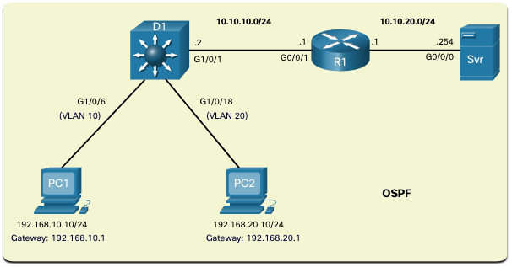

| Device | Interface | IP Address / Prefix |
| --- | --- | --- |
| MLS D1 D1 | VLAN 10 | 192.168.10.1 /24 |
| MLS D1 | VLAN 10 |
| MLS D1 | VLAN 20 | 192.168.20.1 /24 |
| MLS D1 | VLAN 20 |
| MLS D1 | G1/0/1 | 10.10.10.2/24 |
| MLS D1 | VLAN 30 |
| MLS D1 |  | |
| MLS D1 |
| MLS D1 |
| PC1 | NIC | 192.168.10.10 |
| PC2 | NIC | 192.168.20.10 |
| R1 | G0/0/1  NIC | 10.10.10.1/24 |
| PC4 | G0/0/0 | 10.10.20.1/24 |
| Srv | NIC | 10.10.20.254/24 |
| PC5 | NIC |

# Objectives

Part 1: Configure Layer 3 Switching

Part 2: Configure Inter-VLAN Routing

Part 3: Configure OSPF Routing

# Background / Scenario

A multilayer switch like the **Cisco Catalyst 3650** is capable of both Layer 2 switching and Layer 3 routing. One of the advantages of using a multilayer switch is this dual functionality. A benefit for a small to medium-sized company would be the ability to purchase a single multilayer switch instead of separate switching and routing network devices. Capabilities of a multilayer switch include the ability to route from one VLAN to another using multiple switched virtual interfaces (SVIs), as well as the ability to convert a Layer 2 switchport to a Layer 3 interface.

# Instructions

## Configure Layer 3 Switching

In Part 1, you will configure the GigabitEthernet 1/0/1 port on switch MLS D1 as a routed port and verify that you can ping another Layer 3 address.

* + - 1. On MLS D1, configure G1/0/1 as a routed port and assign an IP address according to the Addressing Table.

Open configuration window

MLS D1(config)# **interface g1/0/1**

MLS D1(config-if)# **no switchport**

MLS D1(config-if)# **ip address 10.10.10.1 255.255.255.0**

Close configuration window

## Configure Inter-VLAN Routing

### Add VLANs.

Open configuration window

Add VLANs to MLS D1 according to the table below. Packet Tracer scoring is case-sensitive, so type the names exactly as shown.

|  |  |
| --- | --- |
| **VLAN Number** | **VLAN Name** |
| 10 | Staff |
| 20 | Student |

### Configure SVI on MLS D1.

a. Configure and activate the SVI interfaces for VLANs 10, 20, according to the Addressing Table. The configuration for VLAN 10 is shown below as an example.

MLS D1(config)# **interface vlan 10**

MLS D1(config-if)# **ip address 192.168.10.1 255.255.255.0**

MLS D1(config)# **interface vlan 20**

MLS D1(config-if)# **ip address 192.168.20.1 255.255.255.0**

b. configure g1/0/6 swirtchport mode access belong vlan 10

(**config)# interface g1/0/6**

**(config-if)# Switchport mode access**

**(config-if)# Switchport access vlan 10**

c. configure g1/0/18 swirtchport mode access belong vlan 20

**(config)# interface g1/0/18**

**(config-if)# Switchport mode access**

**(config-if)# Switchport access vlan 20**

### Enable routing.

* + - 1. Use the **show ip route** command. Are there any active routes?

Type your answers here.

No.

* + - 1. Enter the **ip routing** command to enable routing in global configuration mode.

MLS D1(config)# **ip routing**

* + - 1. Use the **show ip route** command to verify routing is enabled.

MLS D1# **show ip route**

Codes: C - connected, S - static, I - IGRP, R - RIP, M - mobile, B - BGP

D - EIGRP, EX - EIGRP external, O - OSPF, IA - OSPF inter area

N1 - OSPF NSSA external type 1, N2 - OSPF NSSA external type 2

E1 - OSPF external type 1, E2 - OSPF external type 2, E - EGP

i - IS-IS, L1 - IS-IS level-1, L2 - IS-IS level-2, ia - IS-IS inter area

* - candidate default, U - per-user static route, o - ODR

P - periodic downloaded static route

Gateway of last resort is not set

C 192.168.10.0/24 is directly connected, Vlan10

C 192.168.20.0/24 is directly connected, Vlan20

C 10.10.10.0/24 is directly connected, GigabitEthernet1/0/1

Close configuration window

End of documense

### configure OSPF routing on MLS D1 and R1 (Module 6_Dynamic_Routing_with_OSPF)

a. Configure **ospf 10 area 0** on MLS D1

b. Configure **ospf 10 area 0** on R1

#### Question:

## Verify Configuration

- **PC1** ping successfully to **PC2**

- **PC1** and **PC2** ping successfully to **Srv**